Chapter 6, Solution 51.

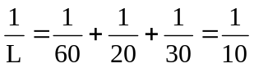 L = 10 mH

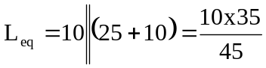

= 7.778 mH

